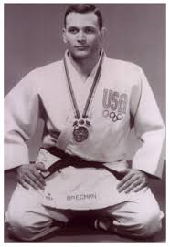
Jim Bregman invites you to…
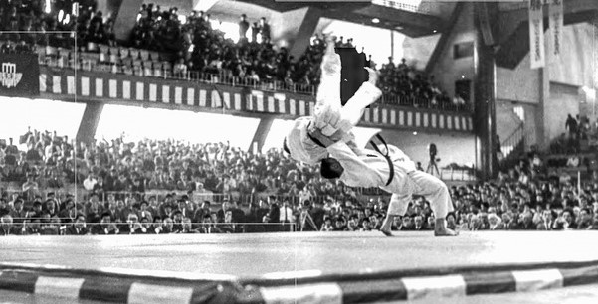
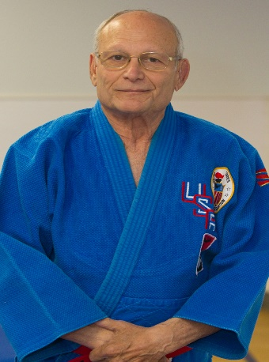
as of 17 June 2022
Jim Bregman won an Olympic Bronze medal at the Tokyo Olympic Games in 1964 and a bronze medal at the World Championships in Sao Paulo, Brazil in 1965. Additionally, he won gold medals at the Maccabiah Games in Israel and the Pan

American Games in Guatemala. He is the USA's first Judo athlete to win an Olympic medal. Since then, he has been the President and a Founder of the United States Judo Association. Sensei Bregman is a 10th degree Black Belt who continues to impact the world of Judo through his recently established "Jim Bregman Invites you to..." series of presentations on various timely and important issues of the day.
A superior text-based interview with Jim Bregman by Mike Belzer about growing up in the art of judo, being a student of Donn Draeger and winning the bronze medal in the 1964 Olympics held in Tokyo, Japan. The full interview is located at:
https://web.media.mit.edu/~reilly/Bregman-interview-05-2020.pdf

There have been terrific presentations in the Jim Bregman invites you to… series. The Web URL and a brief description of each is listed below. The “Jim Bregman invites you to…” series conducted a presentation by IJF-A Referee Rick Celotto. Rick’s presentations were an immediate success, and his single presentation raised a demand for further presentations. Rick Celotto’s presentations and their supporting documents are listed separately (later in this document).
An updated version of the ‘Jim Bregman invites you to…’ program sessions is available at:
https://web.media.mit.edu/~reilly/BregmanUpdate.docx
SAME DOCUMENT different format ALSO AT
https://web.media.mit.edu/~reilly/BregmanUpdate.pdf
Statistics for each presentation are located at:
https://web.media.mit.edu/~reilly/Bregman-Zoom-stats.xlsx

sad

Comments or to report errors send email to Rob Reilly reilly@media.mit.edu

Presentations in the series…

This series is produced by James Bregman, Rob Reilly, and Peter Mantel

Zoom details for upcoming presentations appear on https://www.facebook.com/rob.reilly.750

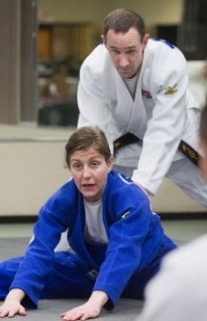
The Complete Judo Experience with Dr. Lisa Capriotti
"Would you categorize Dr. Jigoro Kano as a coach, a referee, or an event director? Did he teach his students shiai or kata? Great judo students and teachers have experience in each of these areas, even if they specialize in one or more. In this talk we will demonstrate why every judo community needs to have a complete judoka, and what you can do to become one."

June 12, 2022 located at: https://youtu.be/NyYIxf8KLvc

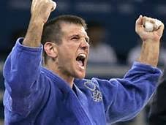
Jimmy Pedro: Becoming an Olympian
The “Jim Bregman invites you to…” program offers a session featuring two-time Olympic medalist and world judo champion Jimmy Pedro. This is a terrifically insightful program into where the USA is on the world scene what a remedy is to our falling status on the international level. Sensei Pedro also offers advice to athletes who desire to compete on the international and Olympic level. Jim Bregman also injects his perspective of the situation. All-in-all this is a terrific zoom session. It is located on YouTube at:

May 2022: located at: https://youtu.be/kO49Mh4ksxo

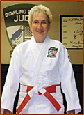
Donna Turk: The Nuts and Bolts of the USJA’s Promotion System…
“Nuts and Bolts of the USJA Promotion System” that will be given by Promotion Board Chair DONNA TURK on Tuesday, April 12, 2022, at 6:00 pm Eastern USA time.
April 12, 2022: This seminar is located at: https://youtu.be/h4EZyWlk-9E
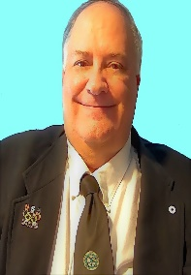
Rick Celotto: 2022 IJF Rules Update… What Has Changed
IJF A Referee RICK CELOTTO regarding the 2022 IJF Rule Changes. This seminar will be presented in Rick’s typical high quality and in-depth manner. There are several documents online so that you could be prepared for this seminar and prepared to ask probing questions.

This seminar is located at: to be announced

The seminar’s documents are in PDF format at:
IJF Rule Update at:
https://web.media.mit.edu/.../IJF_Refereeing_Rules...
Some comments on the rule changes:
https://web.media.mit.edu/.../Lascau_Comments-2022.2.25.pdf
Additional clarifications at:
https://web.media.mit.edu/.../IJF_Rules_update_Sport...
New hand signals located at: (Note: Hand signals video is a bit odd to play. I hope it is online somewhere else!
https://web.media.mit.edu/~reilly/handsignals.mkv
Rick Celotto: Basic Review of Prohibited Acts
This in-depth 2-part seminar presented by RICK CELOTTO (IJF-A Referee) entitled: Basic Review of Prohibited Acts. This will be a review of the 30 Shido prohibited acts and the 13 Hansoku- Make prohibited acts. This review will concentrate on the more frequently applied prohibited acts.
See a list of the penalties to be reviewed at:
https://web.media.mit.edu/~re.../Celotto-prohibited-acts.pdf
same document in Word format at
https://web.media.mit.edu/.../Celotto-prohibited-acts.docx
PART1 (Oct 21, 2021) is available on YouTube at: https://youtu.be/zmYHnpZRYX0
PART 2 (November 7, 2021) is available on YouTube at: https://youtu.be/31ZpAff9k4o

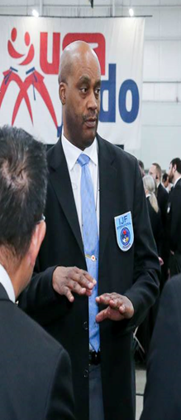
IJF-A Referee Bobby Donaldson: Perspective from My Position

Sensei Donaldson’s Zoom presentation was initially entitled: “Introduction to the Referee Corps: Becoming an IJF-A Referee”. While he reviewed his journey to becoming an IJF-A Referee, Sensei Donaldson’s presentation also provided his very enlightening perspective on Judo from his point-of-view as a career member of the US Navy, a skilled Judo athlete, international traveler, and as an international Referee. Sensei Donaldson provides a number of well-developed insights that will be of-interest to all.
September 21, 2021: https://youtu.be/J2npOecpMxU

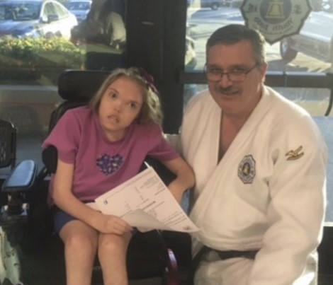
Brian Money & Pedro Villa Jr.: a Special Needs Judo Primer

… a presentation by Brian Money and Pedro Villa Jr., which deals with Special Needs judoka. This presentation includes an overall description of special needs judo. The term special needs can include any students who have disabilities with social interactions, thinking, hearing, seeing, walking, and any other disability that affects their daily activities. Disabilities such as Autism Spectrum Disorder (ASD), Down syndrome, cerebral palsy, intellectual disabilities, and other physical disabilities are included as part of special needs judo. We discuss how special needs judo differs from mainstream judo, including specific rules, athlete levels (1 - 5), and training techniques. Learning and understanding the rules and training techniques used in special needs judo will greatly aide every instructor who has a special needs student in their club. It will also allow us to participate in and enjoy an international judo community that is wholly devoted to these amazing judo athletes.

August 17, 2021 Located at: https://youtu.be/1up1WRZwANE
A Journey Through the Local and Regional Referee Examination.
Your Guide will be Rick Celotto, IJF-A (International) Referee

This is an overview of what is expected when one prepares for and goes through the process of taking the Local or Regional Referee Exam. This seminar covers the prerequisites, preparation, and paperwork. We cover the written examination with sample questions. We also cover the practical evaluation process discussing the categories of evaluation which includes Appearance, Authority, Appreciation (Judgment) and more

May 2021: https://youtu.be/2TBiawiVp3Q
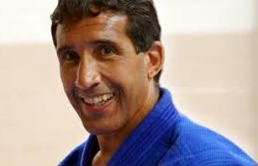
Clyde Worthen: Judo Around the World
USJF Hall of Fame member Clyde Worthen explores Judo training methods and regimens around the world. He also shares his perspective regarding Judo in public/private schools.

May 2021: https://youtu.be/uWX4HzGMgD8

Dr. Lisa Capriotti & Rob Gouthro: Really Basic Referee Course
It is a huge jump from barely knowing any of the Judo rules to attending a National Referee testing event. There are very few, if any, intermediate steps. Plus, many people would be a local or regional referee, but do not wish to referee at the nation level (or above). This session covers the basics of being a local/club referee.
May 2021: Located at: https://www.youtube.com/watch?v=exrsIaEVF0M
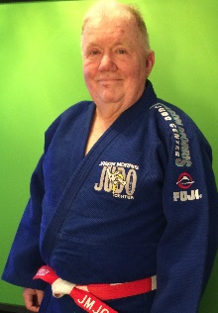
Dr. Rob Reilly: Teaching and Learning are Different!
While teaching methods are important, understanding the learning process will greatly increase a ‘teachers’ ability to produce a skilled judoka. Dr. Reilly provides insight into the learning process from a basic perspective. The Powerpoint used in this presentation is available at: http://www.media.mit.edu/~reilly/TeachvsLearn.pptx
May 2021 Located at: https://youtu.be/vzfAi4KFUqE
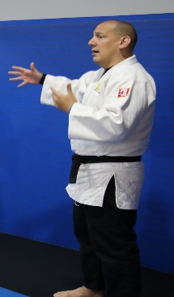

Ramon Hernandez, Developing and driving a Commercial Dojo
A presentation by nationally renowned judo club owner RAMON HERNANDEZ. He will offer many insights into owning, managing, and growing a commercial dojo. Here is the Zoom info for a session that you should not miss:

7 March 2021 Located at: https://youtu.be/zrdDL-YfwuI

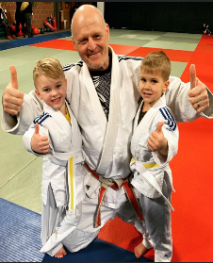
Paul Jordan: Your Dojo: Build it, Manage it, Grow membership

Paul is a dynamic entrepreneur, and judo club owner in Ohio USA. He relates his experiences in judo growing up, starting his 1st dojo in a recreation center, and subsequently moving into his own space, then quitting his job and becoming a full-time judo coach.

14 February 2021 Located at: https://youtu.be/brumgwXH8so
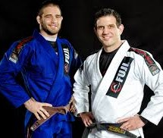
Guided tour of the American Judo System created by Jimmy Pedro & Travis Stevens
This session provides a tour of the ‘American Judo System’ that is a creation of Jimmy Pedro and Travis Stevens. In addition to the tour, Travis offers many interesting thoughts about judo training.
5 February 2021 Located at: . https://youtu.be/w-kmcEkARVI

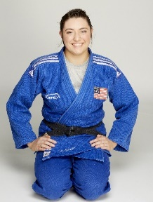
Nicole Stout: Training Tips from an Elite Athlete
Nicole has won many international and national medals. She has been an elite competitor for several years. She shares some of her experiences in randori, training and in-general as an elite athlete.
29 January 2021 Located at: https://youtu.be/Uczf0Sapy-0

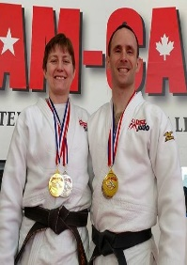
Lisa Capriotti & Rob Gouthro
Lisa Capriotti-Rob Gouthro are multi-time US National Champions in various Katas. Lisa is a world champion in the Veterans Division in shiai. Together with Brad Bolen 6-time USA National Senior Champion, they offer unique insight into kata at a competitive level as well as insight into what judges are looking for
3 January 2021 – Located at: https://youtu.be/BoQ80eNMvy8

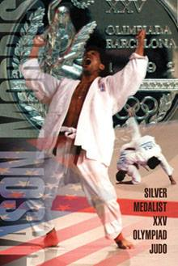
Olympic Silver Medalist Jason Morris on the State of American Judo
Jason Morris provides his perspective on the development and non-development of Judo across the country as well as provides his insight into development needs for the current rimes.
12 December 2020 -- Located at: https://youtu.be/cYwBrBspJdE

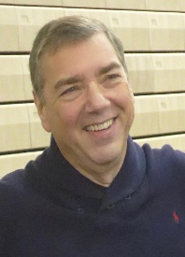
Steve Cohen 2nd Session: State of American Judo

Steve Cohen, former Olympian, and former US Olympic Judo Coach talks about his experiences as the head coach of the US Olympic Judo Team, and offers insights about being the coach of competitive athletes.
7 December 2020 -- Located at: https://youtu.be/91N1wxoH23A
Jimmy Pedro’s perspective on the State of American Judo
A World Judo Champion and 2-time Olympic Bronze Medalist Jimmy Pedro shares his perspectives on the state of American Judo.
3 December 2020 -- Located at: https://youtu.be/OdqBInoKQno

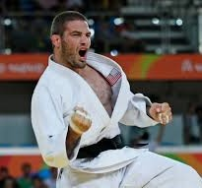
Travis Stevens Judo Seminar
Three-time Olympian and Olympic Silver Medalist Travis Stevens shares his perspective of being an Olympic athlete in the USA's system. There are many gems of wisdom scattered throughout his presentation.
21 November 2020 -- Located at: https://youtu.be/9oRKwqPuv0s

Steve Cohen: State of American Judo
Steve Cohen, former Olympian, and former US Olympic Judo Coach reviews the history of Judo in the USA and talks about the decline of Judo over recent years.
16 November 2020 -- Located at: https://youtu.be/oz_GELsKHX4

Rick Celotto’s 2020 Judo Rules Review (Part 1)
A 2020 RULES REVIEW SEMINAR presented by IJF-A Referee RICK CELOTTO. This is Part 1 in a 4 Part series. Details regarding subsequent videos are located later in this document.
25 August 2020 -- Located at: https://youtu.be/YAJQC9L1Obg

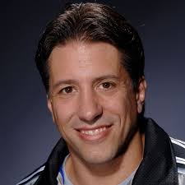
Chat with Olympic Silver Medalist Jason Morris
We offer an insightful, interesting, and informative conversation with JASON MORRIS an Olympic Silver Medalist, US Olympic Coach, and one of the top Judo technicians in the world
7 August 2020 -- Located at: https://youtu.be/KbeDTupb_TI

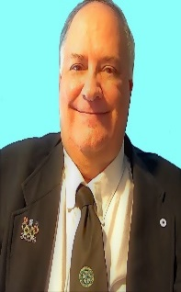
Rick Celotto's Basic Refereeing Seminar
IJF A Referee RICK CELOTTO provides an excellent introduction for those who would like to become referees, or, for beginner referees to improve their knowledge.
More Rick Celotto videos are listed later in this document,
21 July 2020 -- Located at: https://youtu.be/g-ydENJhsXE
Jason Morris: His Perspective on Judo
An insightful, interesting, and informative conversation with JASON MORRIS an Olympic Silver Medalist, US Olympic Coach, and one of the top Judo technicians in the world

12 June 2020 – Located at: https://youtu.be/KbeDTupb_TI
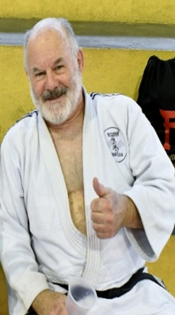
William Stevens Legal Presentation for USA Judo Coaches
As part of a series of planned presentations under the leadership of Jim Bregman, recently retired Massachusetts Assistant Attorney General and 6th degree Black Belt Williams Stevens offers this clinic. It is intended to present a general overview of legal responsibilities with respect to coaches and coaching. It is not legal advice. You must consult with an attorney regarding any specific issues that may occur.
29 May 2020 -- Located at: https://youtu.be/H0A2g5pYjXQ

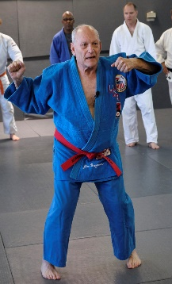
Olympic Medalist Jim Bregman on virtual ashi waza practice.
Clinic by Olympic Medalist Jim Bregman: Solitary Drills... This 48-minute--mini-clinic focuses on ashi-waza. It provides drills for several foot techniques that can be practiced at home without a partner. They are also terrific drills during normal operating times. Note: full screen of Sensei Bregman begins after the 1:10 mark.
21 May 2020 -- Located at: https://youtu.be/6xyTNQfnw-4

Combined Overview Resource Documents
2020 Judo Referee Rules
Rick Celotto, IJF-A Referee

Sources and locations compiled by Mr. Richard “Rick” Celotto, IJF-A (International) Referee. With the efforts of Jim Bregman and Rob Reilly, who made available some of these hyperlinks, we present to all Referees, Coaches, Competitors, Parents and interested parties a one stop resource document for the 2020 Judo Refereeing Rules. And, thanks to the IJF for providing many of these resources.

□ INTRODUCTION—Basic Referee with Rick Celotto Webinar (July 11, 2020)
https://youtu.be/g-ydENJhsXE

□ PART 1-- 2020 IJF Rule Review (August 22, 2020)
https://youtu.be/YAJQC9L1Obg

□ PART 2 -- 2020 IJF Rule Review with Rick Celotto Webinar (September 12, 2020)
https://youtu.be/mycLwdOsqa0

□ PART 3 -- 2020 IJF Rule Review with Rick Celotto Webinar (October 2020)
https://www.youtube.com/watch?v=zGQgyMHFAUA&t=761s

□ PART 4 -- 2020 IJF Rule Review – https://youtu.be/IAfM3pz_4Xc

□ PART 5 – A Journey Through the Local and Regional Referee Examination.
– https://youtu.be/2TBiawiVp3Q

Below are supporting documents for the videos in Rick Celotto’s seminars:

- 2020 IJF Sport Organization Rules (SOR) http://web.media.mit.edu/~reilly/IJF_SOR.pdf
Competition Area Section 8 Pages 91-64
Judogi SOR Appendix C Pages 76-90
Refereeing Rules SOR Appendix D Pages 92-144

- Basic Referee Manual 7/2018 by Rick Celotto
http://web.media.mit.edu/~reilly/Celotto-manual.pdf

- 2017 vs. 2019 IJF Refereeing Rules Articles Comparison Chart:
http://web.media.mit.edu/~reilly/Comparison-Chart.pdf

- 2019 IJF Rule Changes Synopsis: http://web.media.mit.edu/~reilly/Celotto-Synopsis.pdf

- 2020 IJF Video Doha (Player with Slow Motion and Step by Step):
https://refereeusb2020.ijf.org/app/index.html

- IJF Explanatory Guide: http://web.media.mit.edu/~reilly/C%20elotto-explanatory-guide.pdf

- 2020 IJF Refereeing & Coach Seminar - Doha, Qatar Day 1 is located at:
https://www.youtube.com/watch?v=KRkapcuNfl0

8. 2020 IJF Refereeing & Coach Seminar - Doha, Qatar Day 2 is located at:
https://www.youtube.com/watch?v=QLZ_kLDNcq8
9. Quick Guide to Judo (3m40s) https://youtu.be/pgfKasoI5yc

